Course Methods Year 11

Student name: ________________________ Teacher name: ________________

Date: 17/02/20

Task type: Response

Time allowed for this task: 40 mins

Number of questions: 6

Materials required: NO CALCULATOR REQUIRED
NO NOTES REQUIRED

Standard items: Pens (blue/black preferred), pencils (including coloured), sharpener, correction fluid/tape, eraser, ruler, highlighters

Special items: Drawing instruments, templates and formula sheet

Marks available: 37 marks

Task weighting: 10 %

Formula sheet provided: Yes

Note: All part questions worth more than 2 marks require working to obtain full marks.

Question 1 (1.1.6) (2, 2 = 4 marks)

Solve each of the following for $x$.

- $2x-3=11-5x$

- $10-2x=\frac{2x}{3}$

Question 2 (1.1.4, 11.5, 1.1.6) (2, 3, 2, 3 = 10 marks)

Determine the equation of a line that passes through the point $(-4, 6)$ and:

- has a gradient of 3

- passes through the point $\left(2, 5\right).$

- is parallel to the line $2y-4x=-7$.

- is perpendicular to the line $2y-x-8=0.$

Question 3 (1.1.1, 1.1.5, 1.1.6) (3, 2, 2 = 7 marks)

The coordinates $P(2,p)$ and $Q(q+1, 3q-2)$ both lie on the line $y=5x+1$.

- Find:

- the values of $p$ and $q$.

- the midpoint of $PQ$.

- For what value of $m$ does the line $y=mx+2$ not intersect with the line $y=5x+1$? Justify your answer.

Question 4 (1.1.4, 1.1.5) (2, 1, 1, 2, 1 = 7 marks)

The graph below shows cost, $C$, in dollars versus distance $x$, in kilometres, for two different car rental companies A and B. (Assume that parts of distance are charged for proportionately.)

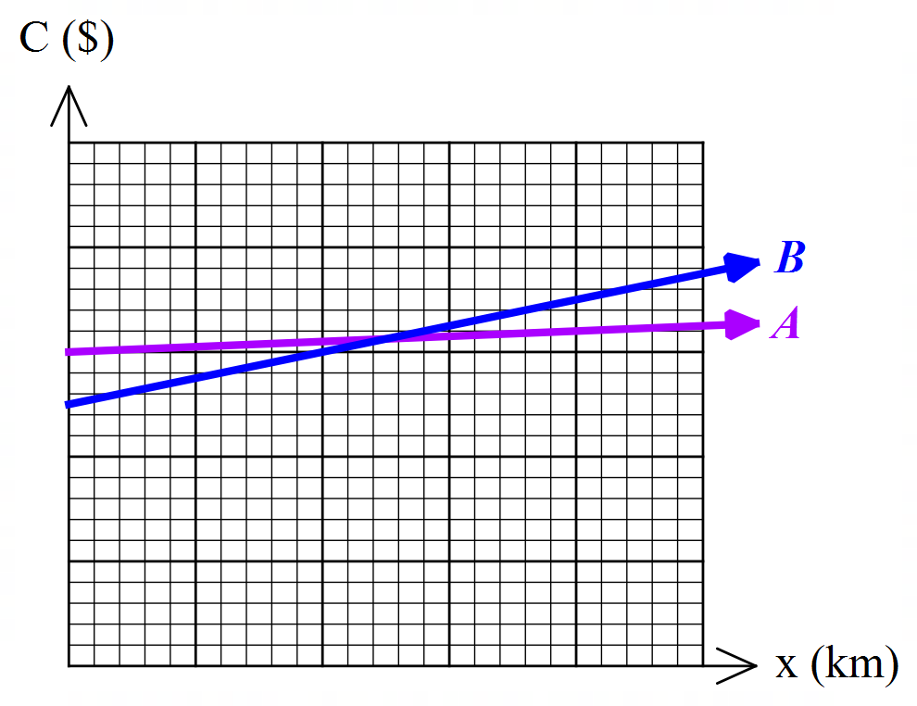

The costs for each company are outlined in the table below.

- Which cost equation corresponds to Company A and Company B?

$$C=250+0.25x$$ | $$C=300+0.05x$$

- Explain what the gradient in the equation $C=250+0.25x$ represents.

- Construct a linear rule for $y=C_{A}-C_{B}$, the difference in cost between Company $A$ and Company $B$.

- Sketch the equation from part c) on the graph below clearly showing all intercepts.
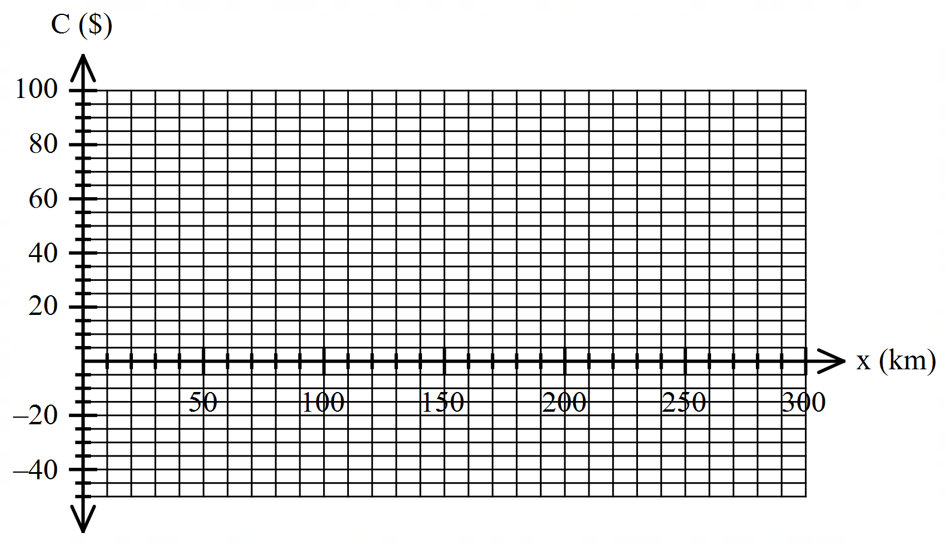

- Using the graph in part d) determine the number of km when the costs of Company $A$ is cheaper than those of Company $B$.

Question 5 (1.1.6) (5 marks)

Solve for $x$, expressing your answer in its simplest form in terms of $a$ and/or $b$.

$\frac{x+a}{b}=\frac{b-x}{a}$ [$a$, $b≠0$]

Question 6 (1.1.6) (2, 1, 1 = 4 marks)

A car travelling at $60 km/h$ takes $t$ hours to go from $A$ to $B$. If the speed of the car is reduced by $10 km/h$, the time to go from $A$ to $B$ is increased by half an hour.

- Construct a linear equation for $t$ using the information given.

- Solve your equation in part a) and hence calculate the value of $t$.

- Find the distance between $A$ and $B$.

END OF TEST

